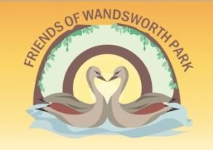

Vision: For Wandsworth Park to be a welcoming, green and vibrant space for all.

To help achieve this vision Friends of Wandsworth Park would work towards ensuring:

- colourful, well maintained plants (trees, shrubs and flowers)
- a thriving, healthy ecology and biodiversity
- that we address the impact of pollution and climate change e.g. via planting, a strong environmental policy
- the development of a hub for community engagement and use e.g. education, information sharing
- improved facilities for users of the park e.g. improved and accessible toilets (see Changing Places guidelines), drinking fountain, telescope, a pond and improved play equipment
- improved sports facilities
- well organised, inclusive community events for local user groups e.g. dog walkers, families, sports groups
- improved community engagement and feedback with all stakeholders including:
  - neighbours
  - dog walkers
  - cyclists
  - park users
  - resident associations
  - Putt in the Park
  - Enable
  - iDverde
  - Prospect Quay Residents’ Association
  - sports groups

The values and approaches underpinning the work of Friends of Wandsworth Park are to be:
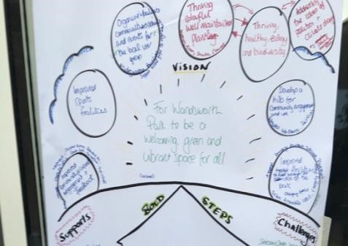
- open and transparent
- community focused
- receptive
- democratic
- developmental
- accountable to all Friends of Wandsworth Park and the wider community
- well managed in our activities

Supports | Challenges
- Friends of Wandsworth Park Committee  - Friends of Wandsworth Park members  - The Wandsworth Forum of Friends Groups  - The London Friends of Green Spaces Network (LFGN)  - idverde Green Space Development Team  - Enable (or the new management)  - Residents Association Prospect Quay  - Local Schools and their Parent Teacher Associations - Local businesses:  - Co-op  - Mindful Chef  - Waitrose  - B & Q  - Homebase  - Context  - MBNA River Boat  - Waterstones  - Putt in the Park  - Hop Pole Pub  - Hurlingham Yacht Club  - TiCL Media Ltd (TiCL)  - The Wetlands Centre  - The Royal Horticultural Society  - Chiswick House and Garden  Trust  - Metropolitan Public Gardens Association (MPGA) | - Finding ways of engaging people to value the park  - Protecting green space from overdevelopment  - Increasing the membership and diversity of people and skills on the committee to plan and ensure sustainability  - Increasing membership  - Dealing with local planning issues  - Developing and maintaining relationships with contractors and the Council  - Limited funds  - Volunteer engagement for events

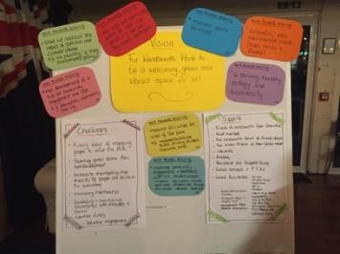
Ideas for action shared at the FoWP AGM 2019.

The 2019 FoWP AGM was hosted on the 3rd September. During the evening the vision and work streams drafted above were shared with the members present.

Members were asked to comment on the vision and work themes. No changes were suggested.

People were then invited to help shape the work of the Friends by sharing their ideas under each of the work steams. A real buzz was created with people really welcoming the opportunity to share their ideas.

The table below details the ideas recorded.

We are keen to ensure people’s ideas are reviewed and acted on wherever possible.

To ensure this these notes ALSO includes notes from the FoWP committee meeting in February 2020 where members reviewed the ideas and agreed action for 2020.

Work Steam  To achieve the vision, we will work to ensure: | 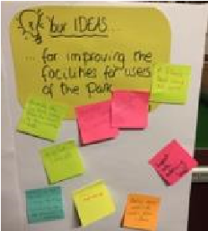  Ideas from Friends of  Wandsworth Park members
- Colourful, well maintained plants (trees, shrubs and flowers) | - Local schools adopt plants/trees  - A wild flower meadow like the one in Fulham Palace  - Please do something with the dark border at the west end of the park. Currently so dull!
Action for 2020 | - Enable have planted shrubs, Hydrangeas, in the border at the west end of the park. These will flower in Spring and Summer  - FoWP have planted Daffodils  - iDverde will be planting Snow Drops which will flower in 2021  - The CRC volunteers are in the part every week so some extra help is available  - Could we create a ‘wilder’ planting scheme just within the Putt in the Park fence at the far east corner of the park? There is some space there with little planting. Lucy Hart, Head Gardner at Fulham Palace may be happy to advise us  - At this point we don’t feel we have the capacity to launch ‘Adopt a Tree’ idea. We are keen to ensure children are welcomed and engaged with the park and aim to host at least one event per year. We did discuss some ideas:  e.g. seasonal walks for groups of children, photo competitions with seasonal exhibitions, link activities with the tree App. Would schools be interested in having planting areas for their children to look after?  Action: We thought it would be a good idea to ask the local schools for their ideas as we need to be realistic in terms of their time and ours.
- A thriving, healthy, ecology and biodiversity | - A wild flower area  - Preserve the trees. Make sure they have Tree Preservation Orders (TPOs). Mature trees are a huge asset!  - The biodiversity walk was fascinating! This should be repeated and perhaps better advertised  - Signage re: the barges in the Thames seen from the park  - More gardens and bedding for people to relax and enjoy  - Bird feeders in a quiet section  - A Bee Hotel for solitary Bees  - A wild flower area
Action for 2020 | - Telescope to be placed in the River Terrace so people can observe the birds on the barges and the Thames.  - Information boards are being designed  - Further develop the River Terrace as a peaceful place to enjoy the planting and the river  - Create some Bug Hotels in the River Terrace – talk to Fiona about this
- Address the impact of pollution and climate change | - More pollution friendly planting  - Develop a ‘green barrier’ along the railings on Putney Bridge Road to adsorb pollution  - Plant along the Putney Bridge road border  - Hedges along Putney Bridge road border  - Planting along the roadside to absorb pollution  - More planting for Bees – wild life generally. Wild flower area?  - Drought tolerant planting  - More plants that attract Bees and Birds
Action for 2020 | - Ian Mitchell from Enable has proposed planting hedging along the fence at Putney ridge Road. Action: Pursue this
- The development of a hub for community engagement and use e.g. education, information sharing | - Maildrop information about FoWP  - Residents association should be engaged with street by street  - Info leaflets in Putt in the Park  - Street by street door knocking to let people know about the park, the benefits, what goes on and the FoWP membership!  - Meet and greet information stand in the park once a month?  - Social media, articles, Instagram, Twitter, Facebook
Action for 2020 | - FoWP stand in the park once a month on a Saturday or Sunday from May – September  - Postcards to be created and give at FoWP stand, to hand out, maybe door drop in local streets and make available at Putt in the Park  - New FoWP notice board is being commissioned
- Improved facilities for users of the park | - Painted cycle lanes (very obvious)  - Cycle lanes  - Re-route cyclists  - Re-route cyclists away from the riverside path to the middle path  - Along with the ‘No Cycling’ signs give the fine – currently the ‘No Penalty’ offense  - Laws need to be enforced  - Display boards about the park’s flora and fauna  - A wooden fitness trail
Action for 2020 | - Investigate wooden/or wood look exercise equipment for the Park. Consider this being places near the Tennis Courts
- Improved sports facilities | - Individual wooden exercise sites e.g. monkey bars etc.  - Outdoor gym  - Establish a football league  - New activities e.g. Drone flying  - A Softball League  - Youth sports teams  - Repair the dangerous pot holes in the Football and Cricket pitches.
Agreed Action for 2020 | - Ask Council/Enable for a fixed time for FoWP to use the sports pitches. We could then advertise this time for local people to us and  - We could host occasional community matches e.g. softball
- Well organised, inclusive community events for local user groups | - Drum up more members for FoWP by opening the next Riverside Terrace party to all. Advertise widely with flyers and posters  - Pam Islip give a talk about Swifts and Swallows  - Host litter picking days  - A permanent `treasure hunt’, with a nature theme, for children with wipe clean boards that could be collected from Putt in the Park
Action for 2020 | - The Treasure Hunt is a little ambitious.  We agreed to add questions to the information boards to engage people.  - Swift talk took place on 25th Feb  - Groups of young people doing Duke of Edinburgh helping with litter picking
- Improved community engagement and feedback with all stakeholders | - Develop the newsletter and social media  - Anything to use the river more – a platform notice board, bird illustrations  - Hold Wandsworth Council to account – advocate  - Any point is having dog poo bag dispensers?  - Try some more popular events
Action for 2020 | - Newsletter is being sent monthly  - Notice boards, with bird illustrations are being designed  - Dog poo bags dispenser’s idea should be researched  - Stall in Putney Exchange promoting FoWP

FoWP Action Plan for 2020
This action plan was drafted in Feb 2020. The aim is to plot the main activities of the year and ensure clear delegation of tasks. To ensure we report on all activity at the 2020 AGM this plan should be updated throughout the year.

PLEASE note that whilst some additional events will be planned the Annual Plan has been created to ensure a flow of activities and avoid ‘overload’.

Month | Activity | Lead person
January | - Tues 14th - FoWP Committee Meeting. | Pat
February | - Tues 25th - Swallow Talk.  - Tues 28th - FoWP Annual Planning  - Tues 25th - Gardening Group. | Fiona  Fiona/Sue
March | - Tues 10th - Gardening Group.  - Tues 10th - FoWP Committee Meeting. | Fiona/Sue  Pat
April | - Sat 28th - Massaria Tree Talk.  (Sally to invite Fleur Anderson MP)  - FoWP Committee Meeting  - New FoWP notice board | Pat
May | - 16th – 24th - Urban Tree Festival and Chelsea Fringe.  - Weekend FoWP Info Stand in the park on one Sat or Sun  - FoWP Committee Meeting
June | - Sun 7th - ‘Cat’s Grin’ Theatre in the Park  - Sun 28th – Square Dance  - FoWP Committee Meeting | Pat  Pat
July | - Weekend: FoWP Stand in the Park  - Bat Walk  - FoWP Committee Meeting | Sue B
August | - Weekend FoWP Info Stand in the park on one Sat or Sun
September | - Sat 5th – Big River Race PLUS FoWP Tea Party and unveiling on the Telescope!  - Bat Walk  - AGM  - FoWP Committee Meeting | Sue B
October | - FoWP Committee Meeting
November | - Tree Walk – plus planting and wishes  - FoWP Committee Meeting
December | - Christmas Party

